ASSIGNMENT 7
Ques 1 A steel beam whose cross section is shown carries a uniform load per unit length (including the weight of the beam) of 29 kN/m. Calculate the maximum bending stress in the beam.
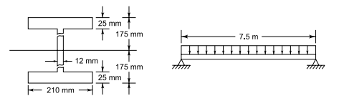

Solution 1
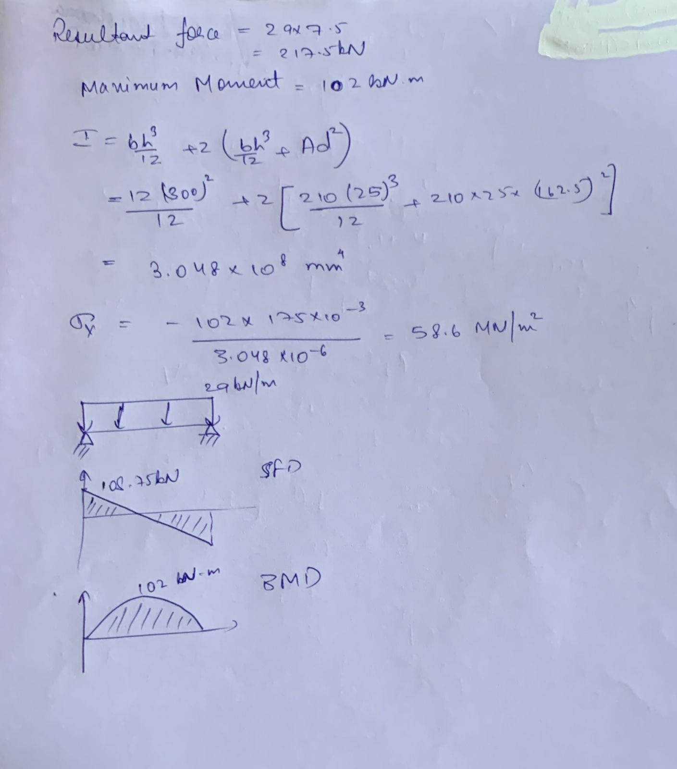

Question 2: A bracket has been loaded as shown in figure. Compute the top and bottom fibre stress at section A-B.
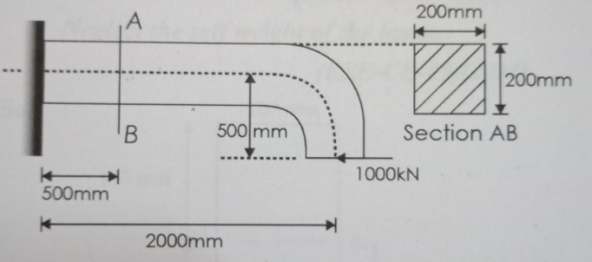
Solution:
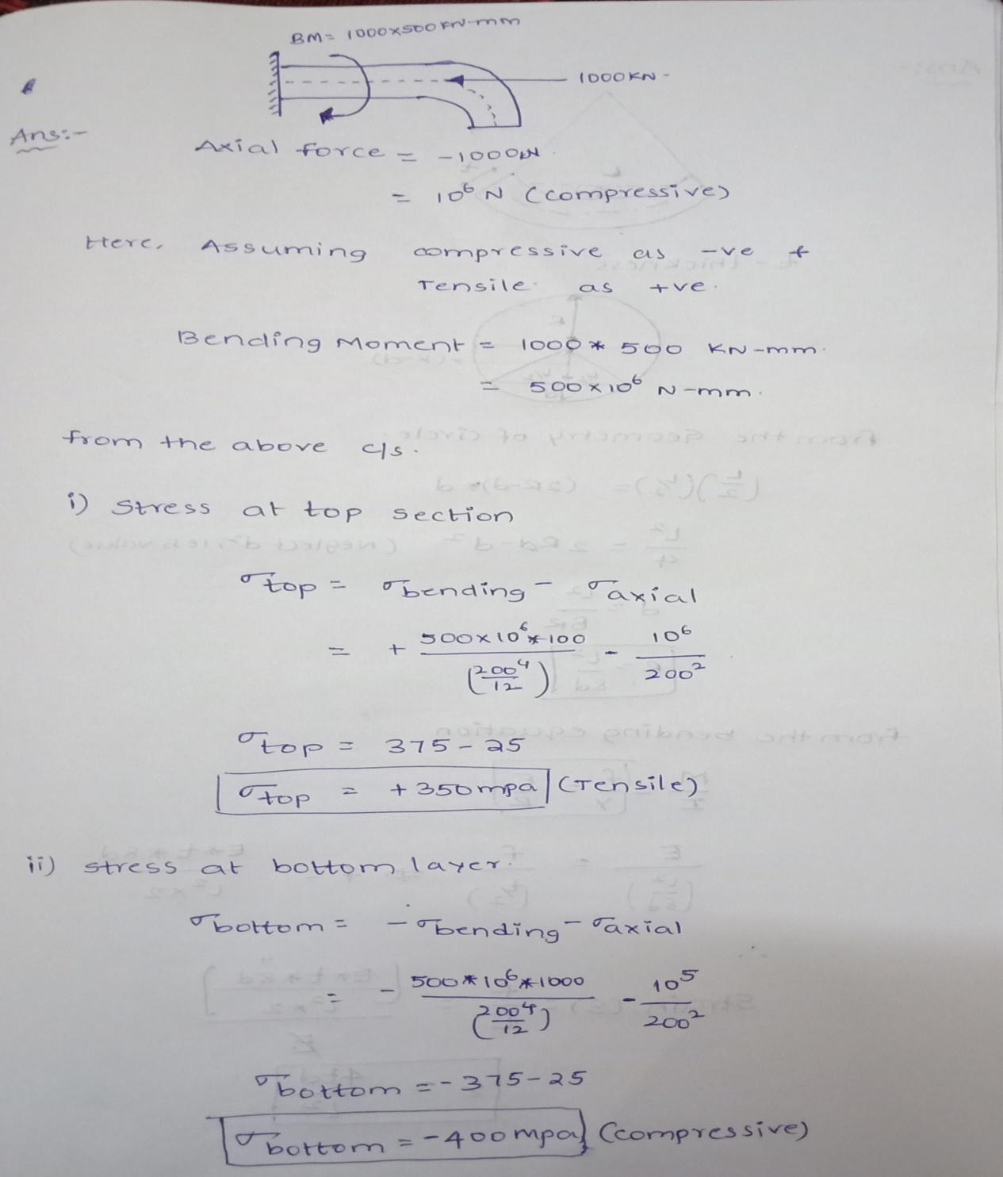

Question 3: A long rod of uniform rectangular section and thickness t, originally straight, is bent into the form of a circular arc and the displacement‘d’ of the mid-point of length L is measured by means of a dial gauge. The displacement‘d’ may be regarded as small compared with length L. show that the longitudinal surface strain in the rod is given by {strain = 4td/L²}.
Solution:
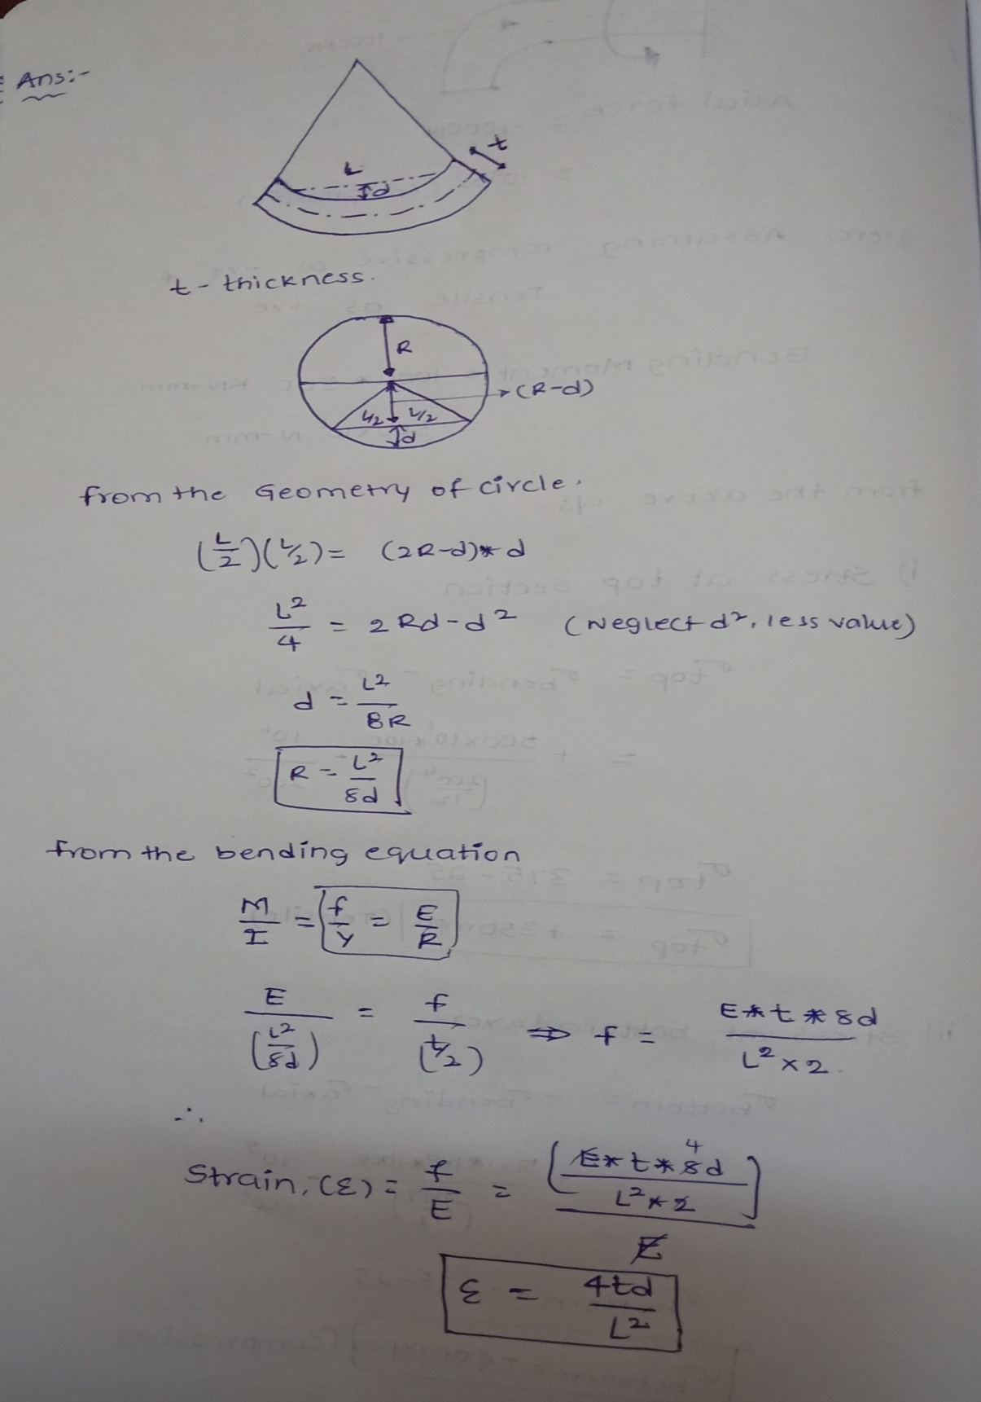

Q4) A strip of copper 40mm wide and 10mm thick is bonded with another strip of aluminium of same size to form a bimetallic strip of 40mm x 20mm. The strip subjected to pure bending moment of 0.2 kN-mt as shown in the above figure. Calculate the radius of curvature of the strip and maximum tensile and compression stresses. E_{c} = 1 x 10⁵ MPa, E_{Al} = 0.6 x 10⁵MPa.
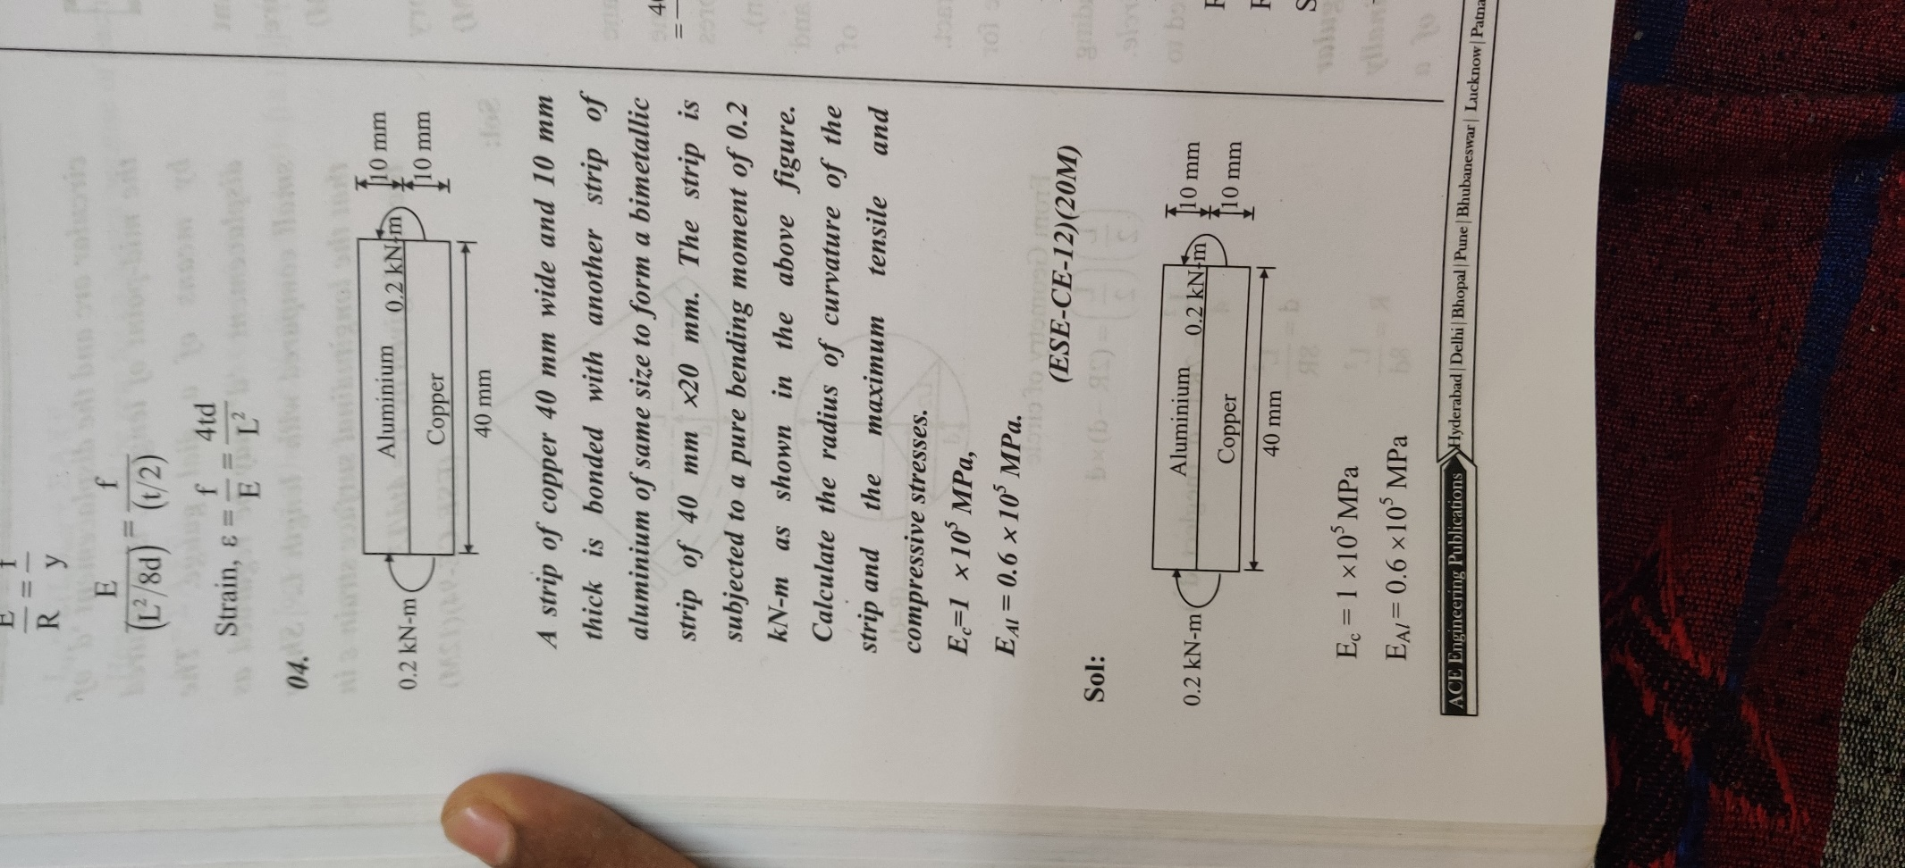
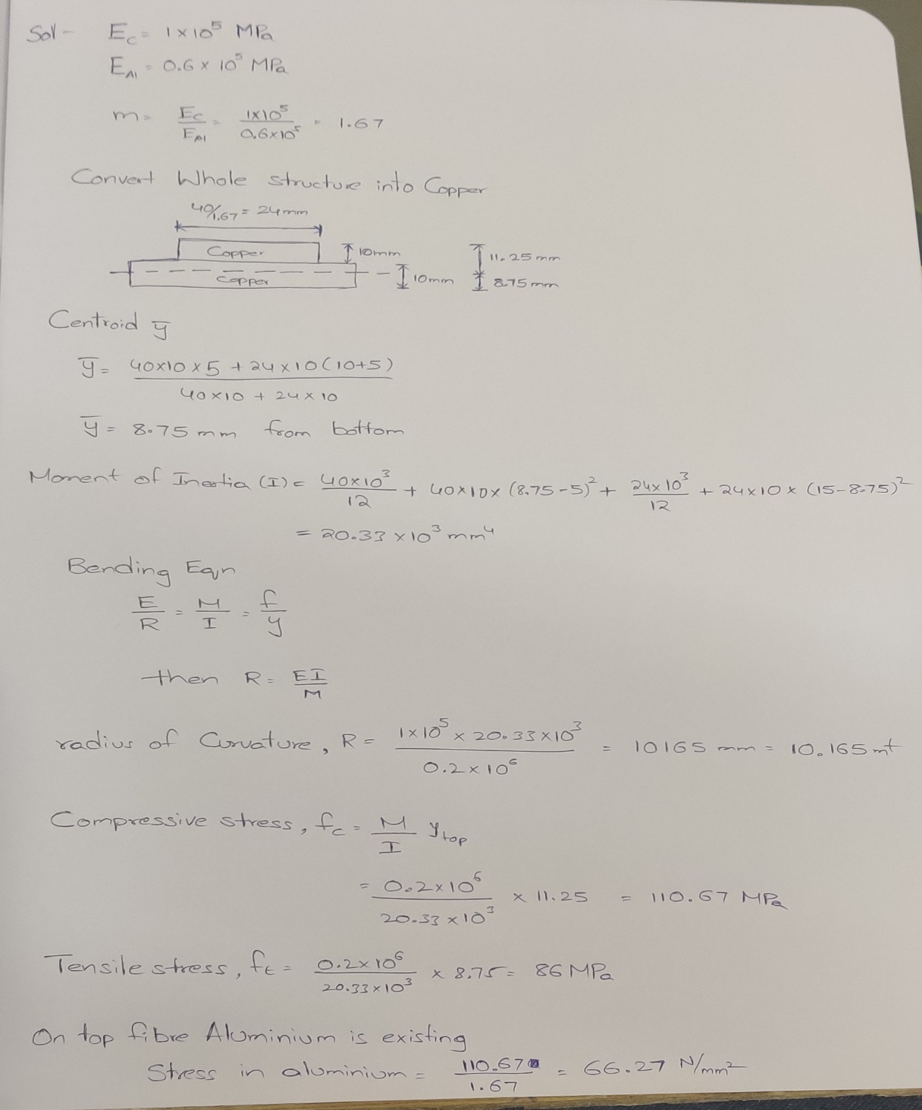

Q5) A new theory of Egyptian pyramid-building proposes that the large pyramid blocks were lifted onto sledges by the counterweighted wooden lever system shown in the figure. The sledges were then pulled up the sides of the pyramid by manpower. If the wood in the levers has an ultimate tensile stress of 55 MN/m² and ultimate shear stress of 15 MN/m². Find on the basis of these ultimate stresses the dimensions of the smallest square piece of timber which will support the pyramid blocks as shown.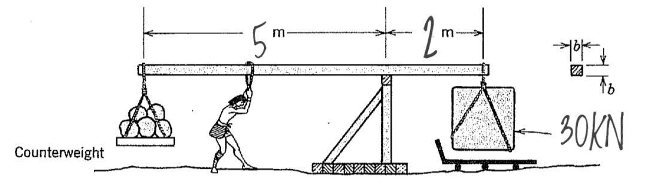
SOL:
